
Université de Versailles Saint Quentin en Yvelines

Institut des Sciences et Techniques des Yvelines
M1 Calcul Haute Performance, Simulation (CHPS)

Rapport du projet d’architecture parallèle :

NBody3D

Élaboré par :

Abdellah DAHOUMANE

Année universitaire : 2022/2023

Partie 1 : Analyse et optimisation

1. Configuration du PC (lscpu):

Architecture: x86_64
CPU op-mode(s): 32-bit, 64-bit
Address sizes: 39 bits physical, 48 bits virtual
Byte Order: Little Endian
CPU(s): 4
On-line CPU(s) list: 0-3
Vendor ID: GenuineIntel
Model name: Intel(R) Core(TM) i5-6198DU CPU @ 2.30GHz
CPU family: 6
Model: 78
Thread(s) per core: 2
Core(s) per socket: 2
Socket(s): 1
Stepping: 3
CPU max MHz: 2800,0000
CPU min MHz: 400,0000
BogoMIPS: 4800.00
Flags: fpu vme de pse tsc msr pae mce cx8 apic sep mtrr pge mc
a cmov pat pse36 clflush dts acpi mmx fxsr sse sse2 ss
ht tm pbe syscall nx pdpe1gb rdtscp lm constant_tsc art
arch_perfmon pebs bts rep_good nopl xtopology nonstop_
tsc cpuid aperfmperf pni pclmulqdq dtes64 monitor ds_cp
l vmx est tm2 ssse3 sdbg fma cx16 xtpr pdcm pcid sse4_1
sse4_2 x2apic movbe popcnt tsc_deadline_timer aes xsav
e avx f16c rdrand lahf_lm abm 3dnowprefetch cpuid_fault
epb invpcid_single pti ssbd ibrs ibpb stibp tpr_shadow
vnmi flexpriority ept vpid ept_ad fsgsbase tsc_adjust
bmi1 avx2 smep bmi2 erms invpcid mpx rdseed adx smap cl
flushopt intel_pt xsaveopt xsavec xgetbv1 xsaves dtherm
ida arat pln pts hwp hwp_notify hwp_act_window hwp_epp
md_clear flush_l1d arch_capabilities
Virtualization features:
Virtualization: VT-x
Caches (sum of all):
L1d: 64 KiB (2 instances)
L1i: 64 KiB (2 instances)
L2: 512 KiB (2 instances)
L3: 3 MiB (1 instance)
NUMA:
NUMA node(s): 1
NUMA node0 CPU(s): 0-3
Vulnerabilities:
Itlb multihit: KVM: Mitigation: VMX disabled
L1tf: Mitigation; PTE Inversion; VMX conditional cache flushe
s, SMT vulnerable
Mds: Mitigation; Clear CPU buffers; SMT vulnerable
Meltdown: Mitigation; PTI
Mmio stale data: Mitigation; Clear CPU buffers; SMT vulnerable
Spec store bypass: Mitigation; Speculative Store Bypass disabled via prctl
and seccomp
Spectre v1: Mitigation; usercopy/swapgs barriers and __user pointer
sanitization
Spectre v2: Mitigation; Retpolines, IBPB conditional, IBRS_FW, STIB
P conditional, RSB filling
Srbds: Mitigation; Microcode
Tsx async abort: Not affected

2. Mesure de performances :

2.1/ Performances avec gcc :
- En utilisant le flag d’optimisation -O1 :

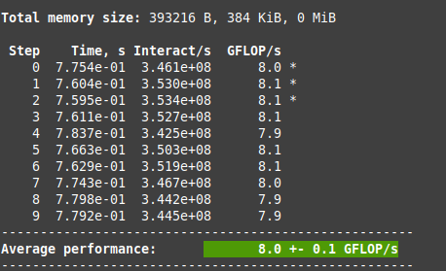

- En utilisant le flag d’optimisation -O2 :
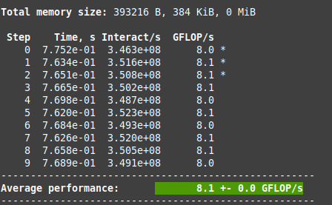

- En utilisant le flag d’optimisation -O3 :
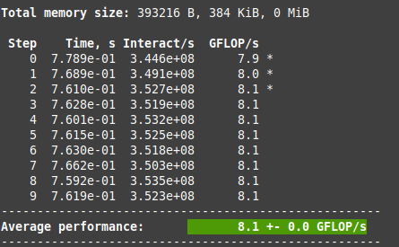

- En utilisant le flag d’optimisation -Ofast :

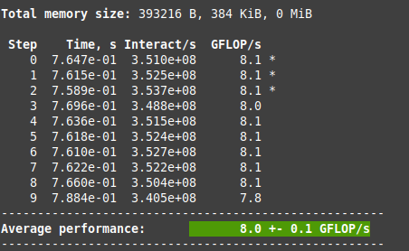

Partie 2 : Résumé de publication (Gravitational N-body Simulations)

In physics and astronomy, the N-body simulation is a simulation of a dynamical system of particles, usually under the influence of physical forces, such as gravity. In the context of a system of N particles interacting gravitationally, the dynamic is described by Newton’s law plus. Thus the problem is a set of non-linear second order ordinary differential equations relating the acceleration with position of particles. It exists a unique analytical solution only for up to two bodies, where larger N require numerical integration. Thus constant timestep methods are unable to guarantee a given accuracy in the case of gravitational dynamics. Due to that, physicists have developed a range of numerical techniques aimed at obtaining a reliable numerical solution with the minimum amount of computational resources, depending on the astrophysical problem of interest.
The most appropriate technique to use depends on the timescale and collisionality of the problem, and can be applied to many different astrophysics problems. Based on those considerations, four main astrophysical domains for N-body simulations can be identified, each requiring a different numerical technique to guarantee maximum performance and accuracy: Celestial mechanics, Dense stellar systems, Sphere of influence of a massive BH at the center of a stellar system and Galaxy dynamics and cosmology.
Direct methods do not introduce approximations in the solution of the equations of motions and thus deliver the highest accuracy at the price of the longest computation time, of order O(N²) per timestep : The tree code method (Barnes & Hut 1986) provides a fast, general integrator for collisionless systems, The resulting computation time scale as O(N log(N)) but the approximations introduce errors. The errors in the long-range component of the gravitational acceleration are controlled by a single parameter (the so called opening angle) that determines how small and distant a group of particles must be to use the approximation. The Fast Multipole Method (Greengard & Rokhlin 1987) exploit the fact that nearby particles will be subject to a similar acceleration due to distant groups of particles. and uses a multipole expansion to compute the force from a distant source cell within a sink cell. This additional approximation of the gravitational interaction was claimed to reduce the complexity from O(Nlog(N)) to O(N). The particle mesh method represents another route to speed up direct force evaluation for collisionless systems. In this case the gravitational potential of the system is constructed over a grid starting from the density field and by solving the associated Poisson equation.The method achieves a linear complexity in the number of particles and (O(Ng log(Ng )) in the number of grid cells. the Adaptive Mesh Refinement (AMR) method concentrates the grid elements where a higher resolution is needed. One possibility to obtain an adaptive resolution is to first construct a low-resolution solution of the Poisson Equation and then to progressively refine regions where the local truncation error is highest. Self consistent field methods are used in the variant of the Particle Mesh code where the expansion of the density and potential of the system are in terms of a basis of orthogonal eigenfunction. This method guarantees at fixed computational resources a higher accuracy than the tree code and the particle mesh algorithms, provided that the set of basis function is appropriately selected. P³M (Hockney & Eastwood 1988), for « Particle-Particle-Particle-Mesh » couples a mean field description on large scales with a direct, softened, treatment of the gravitational interactions on distances of the order or below of a few grid spacing. Adaptive P³M codes have a computational cost which scales as O(Nlog(N )). Another possibility is to resort to a tree code for the short range force evaluation leading to a hybrid PM-Tree scheme. Computational Celestial Mechanics refers to a series of methods targeted at studying the dynamics of small N systems (N <= 20). It requires extremely high precision given the chaotic nature of the N-body problem.
As an alternative to particle based N-body methods, the dynamics of a system of particles interacting gravitationally can be followed by solving the time dependent Boltzmann Equation coupled with the self-consistent Poisson equation which is known as mean field methods. The first approach is the Grid based solvers for the Collisionless Boltzmann Equation. This approach can take advantage of standard computational methods developed to solve partial differential equations. However it requires to solve a highly dimensional (6D+time) non-linear system of partial differential equations. The second approach is the Fokker-Planck and Monte Carlo methods These methods solve the collisional Boltzmann equation starting from a given distribution function and by following test particles in the six dimensional position-velocity phase space. The complexity of Monte Carlo codes is linear with the number of particles and thus a realistic number of particles can be used for simulations of collisional systems with N > 105 with a serial code.
In presence of a strong gravitational field, such as that in the proximity of the event horizon of a black hole, N-body simulations cannot be based on Newtonian physics, but must take into account a general relativity framework. As a numerical solution of the Einstein equation is extremely challenging, Post-Newtonian approximations are used when the gravitational field does not deviate too much from the Newtonian case.
An alternative approach to increase the efficiency of numerical solution of the N-body problem is to optimize the hardware. Along side the possibility to use Graphic Cards (GPUs) to carry out the cpu intensive force evaluation.
In addition to the availability of stand-alone codes, several software environments have been created that contain various tools to set up initial conditions, run simulations, and analyze and visualize their results.

